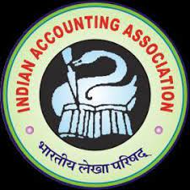
INDIAN ACCOUNTING ASSOCIATION

A Discussion on
“Blockchain Accounting and Cryptocurrencies.”
is being organized by
Indian Accounting Association, Kota Branch
(12th December, 2022, Monday.)

Event Report
- Objectives:-

- Basics of Blockchain Technology.
- Need of Blockchain Technology.
- Application of Blockchain Technology in the real world situations.

- Key note Speaker: Prof Shurveer Bhanawat, HOD, Dept. of Accounting, Mohanlal Sukhadia University, Udaipur.

- Chairman: Dr. Ashok Kumar Gupta, Principal, JDB Girls Arts college Kota Rajasthan & President, IAA Kota branch

- Head of the department : Dr. Anukrati Sharma, Associate Professor, University of Kota.

- Organizing Secretary: CMA Dr. Meenu Maheshwari, Associate Professor, University of Kota & General Secretary, IAA Kota branch.

- Joint Secretary: Mrs. Pragya gaur, Mrs. Nupur Tiwari

Program Summary

Block chain technology is advancing quickly and does not appear to be slowing down. Many things that looked inconceivable in the last few decades—like excessive transaction costs, double spending, net fraud, recovering lost data, etc.—turned out to be true, but because to block chain technology, all of this may now be avoided. In this light, Indian Accounting Association, Kota branch has organized a Discussion on “Blockchain Accounting and Cryptocurrencies.” on 12th December, 2022 at Department of Commerce and Management, University of Kota, Kota.
In the beginning of the session, Dr. Meenu Maheshwari welcomed Prof. Shurveer Bhanawat, HOD, Dept. of Accounting, Mohanlal Sukhadia University, Udaipur in her congenial words and shed a light on career and achievements of Sir. Then, sir took the charge of the session.
The session began with introduction of Blockchain Technology. Prof. Bhanawat sir enlightened us with the growing importance of Blockchain Technology. He stated that knowledge on this vital application of Blockchain Technology is significant for various industries. Moreover, Sir deliberated about the existence, significance and relevance of cryptocurrency in contemporary world. This helped the participants to understand critical concepts of Blockchain technology and Cryptocurrency. Further, Prof Bhanawat explained the concept of Hashing, how the hashing algorithm is created? Concept of Genesis block, Data encryption standard and public key and private key.
The organizer of the event Dr. Meenu Maheshwari rendered the vote of thanks to The Prof Bhanawat. A group photograph along with Dr. Anukrati Sharma, Dr.Anita Sukhwal and Mr.Ashish Asopa ,all the participants and organizers was taken in the end. The event enlightened the scholars and faculties with the application and relevance of Blockchain Technology. The Event ended at a memorable note as the all participants shared their positive feedbacks, related queries.

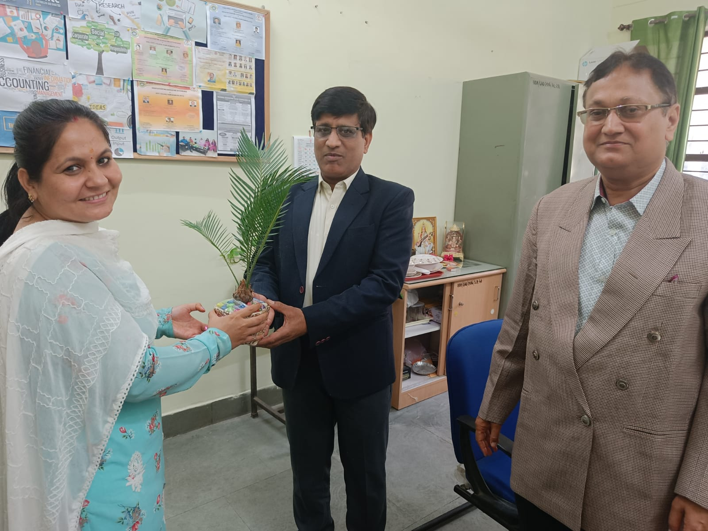
Some glimpses of the event

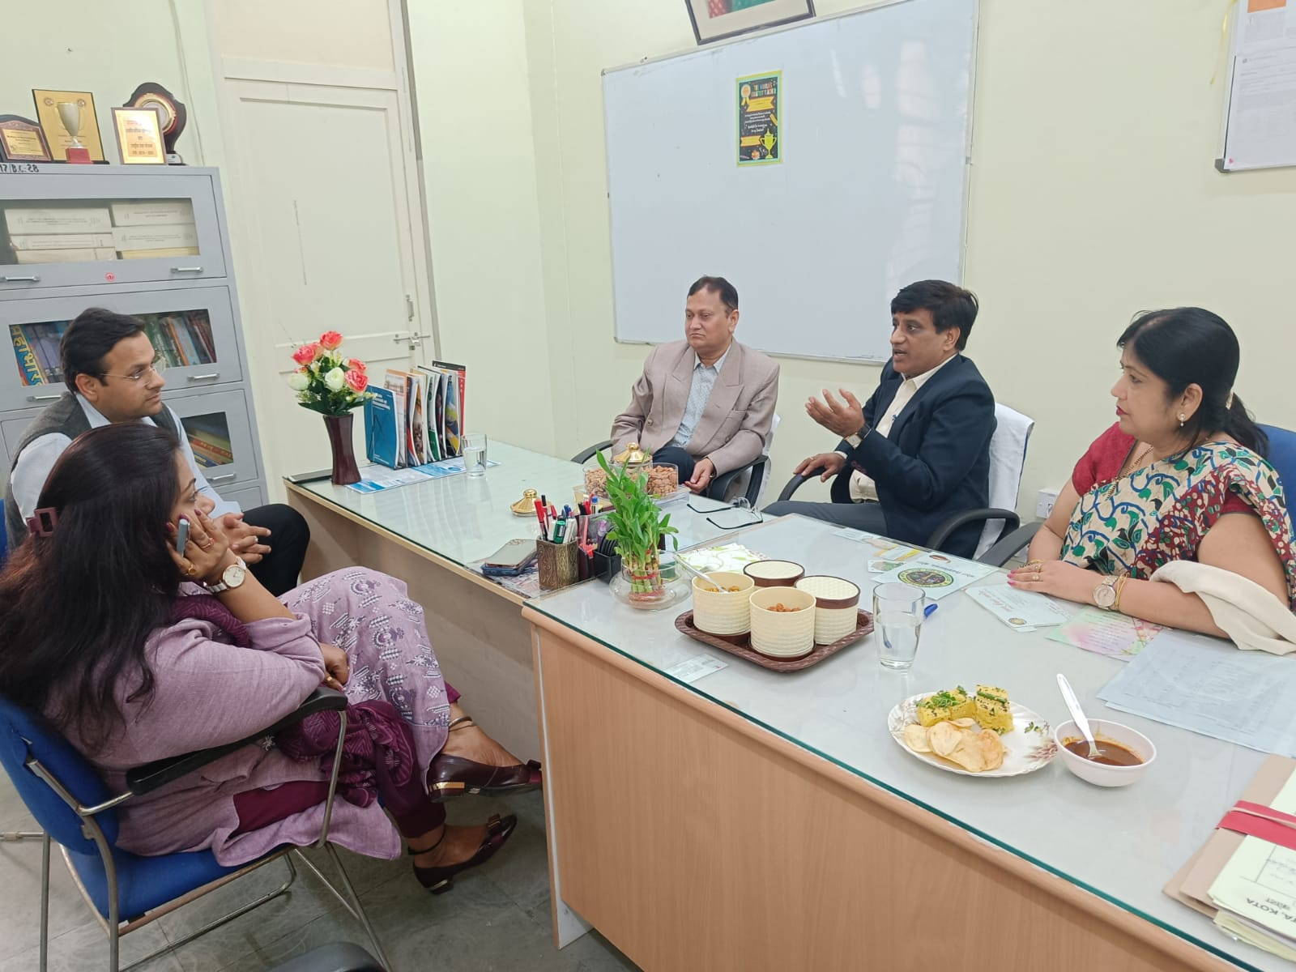
Mrs. Pragya Gaur welcoming Prof Bhanawat sir.

Prof Bhanawat sir delivering session

